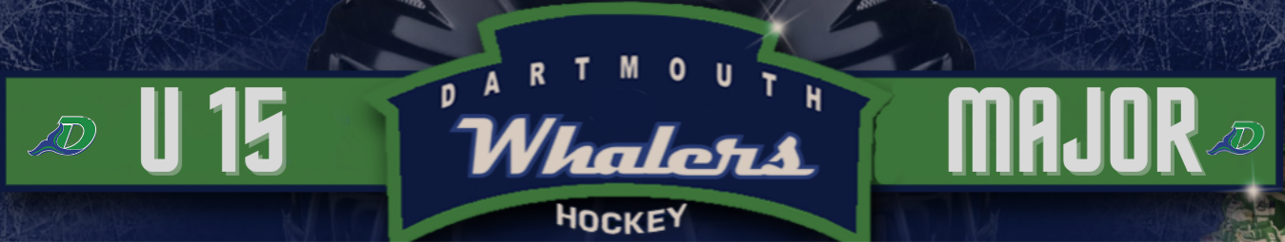
Dartmouth Whalers U15 Major Hockey Club
PLAYER REGISTRATION FORM
Player’s Name: _________________________________________________________
Address: ___________________________________________________________________
City: ___________________________ Postal Code: _______________________________
Date of Birth (Day/Month/Year): ________________ Medical Insurance #: ________________
E-Mail (s): ____________________________________________________________
Parents/Guardians Names: ___________________________________________________
Phone (H): ___________ Phone (W): _______________ Phone (Cell): ________________________
2020-2021 Team: __________________________________ Level: __________________________
Position: _____________ Shot: __________ Height: __________ Weight: ___________________________
2020 -2021 Coach: _______________________________ Phone: ________________________
Attended a HNS approved checking clinic in 2020 or 2021: YES NO (please circle - note this does not apply to goalies)
I, ________________________________ acknowledge that participation in athletics and recreation activities involves the risk of personal injury. In consideration of the use of the facilities, premises and equipment of the Dartmouth Whalers U15 Major Hockey Club by myself and/or my child for athletics and or recreation activities I accept that risk, on behalf of myself and or my child, regardless of the nature of the injury. I agree and understand the Dartmouth Whalers U15 Major Hockey Club, its officers, employees, agents and representatives shall not be liable for any personal injury, death, loss of property or damage as a result of my child's participation in athletics and/or recreation activities with Dartmouth Whalers U15 Bantam Hockey Club, whether caused directly or indirectly by the fault or negligence of the Dartmouth Whalers U15 Major Hockey Club, it officers, employees, agents or representatives or otherwise. I hereby release, indemnify and hold harmless the Dartmouth Whalers U15 Major Hockey Club, its officers, employees, agents or representatives of and from all claims, causes of action, costs, expenses or demands which myself, my child, my heirs, executors, administrators or assigns may have with respect to any such injury, death, loss or damage.
Parent/Guardian Signature: ______________________________________ Date: __________________________
Witness Signature: __________________________________________________ Date: ______________________
Please forward (Phase 1) a cheque or e-transfer dated August 9th, 2021 for $150.00, (Phase 2) a second cheque or e-transfer dated August 24th, 2021 for $150.00 and (Phase 3) a cheque or e-transfer dated August 31st, 2021 for $150.00 payable to the ‘Dartmouth Whalers Major Bantam Hockey Club’ and a completed Player Registration Form, Medical Information Form and Suspension Disclosure Form to:
Chris Guildford, General Manager Dartmouth U15 Major Hockey Club
38 Gourok Avenue Dartmouth, NS B2X 2W8 Email : dartmouthu15major@gmail.com
Registrations are due by AUGUST 9th
Dartmouth Whalers U15 Major Hockey Club
MEDICAL INFORMATION (Please complete all sections)
NAME: _______________________________________________________________________________
ADDRESS: _____________________________________________ POSTAL CODE: ________________
PARENTS:_______________________ PHONE 1:___________________PHONE 2:_________________
MEDICAL CARD NUMBER: ________________________________________________
PERSONS TO CONTACT IN CASE OF EMERGENCY AND PARENTS ARE NOT AVAILABLE:
EMERGENCY CONTACT:_________________________________ PHONE: _____________________
ADDRESS: __________________________________________________________________________
EMERGENCY CONTACT:______________________________ PHONE: ____________________
ADDRESS: ______________________________________________________________________________
DOCTOR: __________________________________________ PHONE: _____________________
DENTIST: __________________________________________ PHONE: _____________________
PLEASE CIRCLE THE APPROPRIATE RESPONSE BELOW PERTAINING TO YOUR CHILD:

Yes No Previous history of concussions
Yes No Fainting episodes during exercise
Yes No Epileptic
Yes No Wears Glasses
Yes No Are lenses shatterproof
Yes No Wears contact lenses
Yes No Wears dental appliance
Yes No Hearing problem
Yes No Asthma
Yes No Trouble breathing during exercise
Yes No Heart Condition
Yes No Diabetic
Yes No Has had an illness lasting more than a week in the past year
Yes No Medication
Yes No Allergies
Yes No Wears a Medic Alert Bracelet or Necklace
Yes No Has health problem that would interfere with participation on a hockey team?
Yes No Has had Surgery in the last year
Yes No Has been in hospital in the last year
Yes No Has had injuries requiring medical attention in the past year
Yes No Presently injured
Please provide details if you answered Yes to any of the above items, use a separate sheet if needed.
Medications: _____________________________________________________________________________
________________________________________________________________________________________
________________________________________________________________________________________
Allergies ________________________________________________________________________________
________________________________________________________________________________________
________________________________________________________________________________________
Medical Conditions: _______________________________________________________________________
________________________________________________________________________________________
________________________________________________________________________________________
Recent Injuries: __________________________________________________________________________
________________________________________________________________________________________
________________________________________________________________________________________
Last Tetanus Shot ________________________________________________________________________
Any information not covered above: ___________________________________________________________
________________________________________________________________________________________
________________________________________________________________________________________
Any medical condition or injury problem should be checked by your physician before participating in a hockey program.
I understand that it is my responsibility to keep the team management advised of any change in the above information as soon as possible and that in the event no one can be contacted, team management will take my child to hospital/physician if deemed necessary.
I hereby authorize the physician and nursing staff to undertake examination, investigation, and necessary treatment of my child.
I also authorized release of information to appropriate people (coach, physician) as deemed necessary.
Signature of Parent or Guardian: _________________________________________

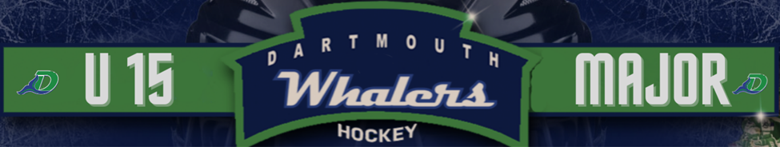
Dartmouth Whalers U15 Major Hockey Club

SUSPENSION DISCLOSURE FORM
Disclosure of carry over suspensions from the 2020–2021 season is mandatory. A carry over suspension is a suspension that was incurred in the 2020–2021 season such that the player was not able to play enough games to fully serve the suspension. If this is the case the suspension will carry over to the 2021-2022 regular season.
A carry over suspension will not prevent a player from participating in our Training Camp, including exhibition games. A carry over suspension will prevent a player from playing any regular season games or tournament games in major bantam until the remaining number of games is to be served, have been served.
Please complete either Section 1 OR Section 2 below and return with your registration package.
Section 1 – I HAVE A CARRY OVER SUSPENSION
Date of Penalty: Teams involved in game:
Penalty: Number of games in suspension:
Number of games served: Remaining Number of Games to be served:
I hereby certify the above fully and accurately discloses the suspension status of .
I understand failure to fully disclose a carry over suspension will result in further suspensions from both the Nova Scotia U15 Major Hockey League and the Dartmouth Whalers U15 Major Hockey Club.

Date Player’s Signature
Date Parent / Guardian Signature
Section 2 – I DO NOT HAVE ANY CARRY OVER SUSPENSIONS
I hereby certify that I, do not have ANY carry over suspensions from the 2020-2021 season and furthermore any suspensions incurred in the 2020-2021 season have been fully served. I understand failure to fully disclose a carry over suspension will result in further suspensions from both the Nova Scotia U15 Major Hockey League and the Dartmouth Whalers U15 Major Hockey Club.
Date Player’s Signature
Date Parent / Guardian Signature

